Ideas (Website)

Suitable for all devices (For computer screen, tablet screen and phone screen using MDL)

Computer Languages used : HTML,CSS and JS. Maybe some Python or Java

Text / Voice analysis for mental health problem (Google Dialog Flow)

Core features

- Knowledge base (Provide awareness of mental health) - Easy

- Scrape info from website

* User matching (AI) -
  + The app will collect your data and then perform clustering by grouping people with similar problems together.
  + Schedule meetings for each cluster. Can assign a trained consultant for each meeting.
  + Match users based on preference and their choices

- Progress tracking

- Both user will track their progression based on the task completed by the user

- Send email or text to check with their other party on the progress

- Simple checklist for user to check if they complete the task

Journalling

* Write a journal or something. The app will evaluate the level of your problem.
* A separate thing can be done anytime.
* Recommend plans

Hotline (Easy)

* Befrienders
* Login and Sign-In Page
* The app will take note of the user’s problems by asking the user to share their own problem. After that, the user will be placed automatically into a group where people will discuss their problem?
* After the user has stated their problem in a journal, the app will recommend a step by step guide (incremental app)
* After another month, the user will state their problem in a journal again and the app will adjust it’s recommended plan based on how optimistic or pessimistic the user has become.
* Can straight away connect with BeFrienders (Small Picture in the app that the user can click on?)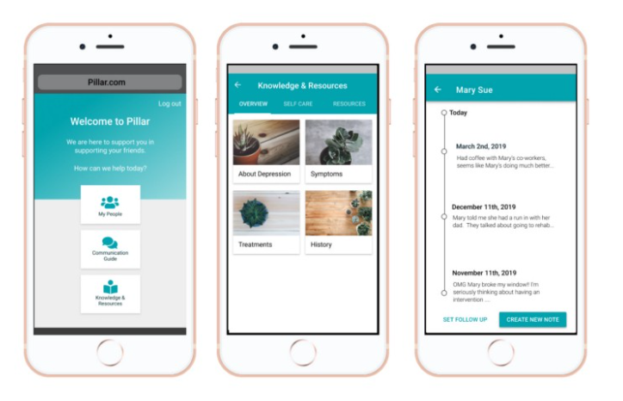
* Add on - match user with trained consultant
  + - Allow both side to track progress on a ‘notes page’ or progress tracker
    - Schedule regular calls

<https://medium.com/hackmentalhealth/being-a-pillar-for-a-loved-one-in-need-a-hackathon-story-420ee83dd3da>

<https://github.com/AndrewYinLi/mindly/blob/master/database.py>

Recommended plans may include meditations or light exercises. Maybe a good diet (A difference in food diet may help).

The sequence of the application

When the user opens the application, a login and signup will appear asking the user for an email address and a password. After that, the user will be directed to the main page

HTML pages involved

Index.html -> main page

**Seven common types of mental disorders include:**

* Depression.
* Anxiety **disorders** such as generalized anxiety **disorders** social anxiety **disorders**, panic **disorders**, and phobias.
* Obsessive-compulsive **disorder** (OCD)
* Bipolar **disorder**.
* Post-traumatic stress **disorder** (PTSD)
* Schizophrenia.

Depression

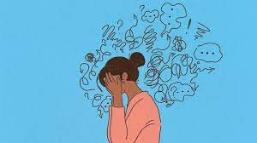

Anxiety Disorders

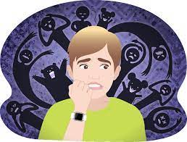

OCD (Obsessive-Compulsive Disorder)

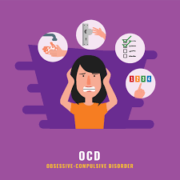

Bipolar Disorder

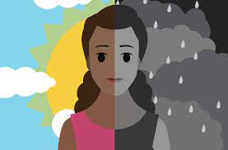

PTSD (Post Traumatic Disorder)

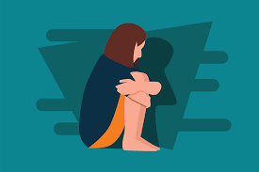

Schizophrenia

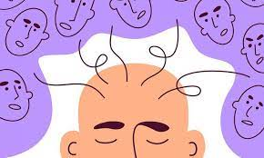

Psychosis

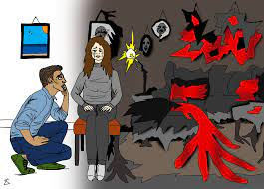

Website for the details

<https://www.betterhealth.vic.gov.au/health/ServicesAndSupport/types-of-mental-health-issues-and-illnesses#psychosis>